**Travel Agency Data Visualization Report**



Author:

Mayah Bosworth

**Table of Contents**

**FOR EXECUTIVES 3**

PRIMARY AUDIENCE MEMBERS FOR REPORT 3

YOUR PRIORITIES 3

ACTIONS TO TAKE 4

POTENTIAL BENEFITS OF ACTIONS 4

POTENTIAL RISKS FOR IGNORING ACTIONS 4

**STORYBOARDING 4**

GENERAL COMPANY INSIGHTS 4

STANDARD PACKAGE INSIGHTS 5

DELUXE PACKAGE INSIGHTS 6

**EXECUTIVE SUMMARY & TABLEAU WORKBOOK 7**

EMAIL DELIVERABLES FOR AUDIENCE MEMBERS 7

TABLEAU WORKBOOK FILE 7

# **For Executives**

### Primary Audience Members for Report

* Marketing team
* CEO
* Vice Presentation of Marketing

### Your Priorities

* Finding a target group to cater towards to increase next year’s sales
* Increasing effectiveness of marketing techniques
* Increasing next year’s sales
* Increasing conversion rate

### Actions to Take

* Concentrate marketing efforts towards targeted groups
* Come up with marketing campaigns that focus on targeting the insights provided in this report

### Potential Benefits of Actions

* Sell more packages and increase our sales
* Reach a wider audience

### Potential Risks of Ignoring Actions

* Wasting money, staying static

# **Storyboarding**

# 

**Report on Visuals**

### General Company Insights

**Trips Sold Last Year:**

This visual shows the amount of travel packages bought, filtering the five different types of packages the company offers. The purpose of this visual is to introduce last year’s sales overview. Based on this data the audience can gain a general sense of how the company performed internally in terms of the number of products sold. The important part of this visual is the size of the rectangles, not the labels which is why they are kept small.

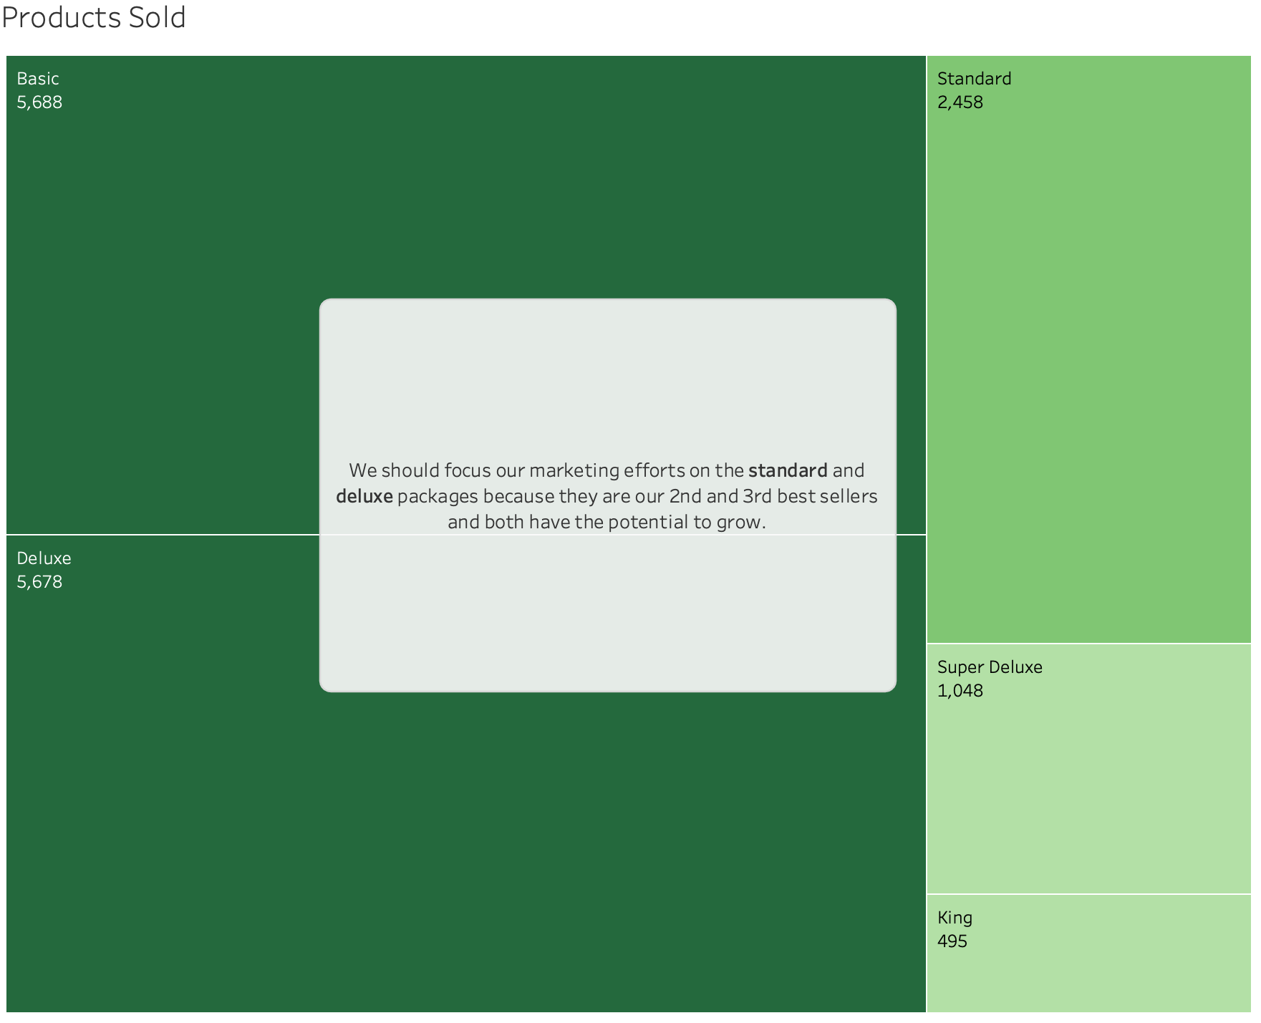

**Customers Finding Out About Our Product:**

After showing the total count of each product sold, we look at how customers are finding out about the company’s product. Since the presentation focuses on improving marketing strategies, introducing this graph early on in the presentation is appropriate. This graph shows how customers are finding out about our company based on the package the customer purchased. A stacked bar chart was used to display this data because it is easy to see how across all packages, customers are finding out about the company’s product in a similar way.

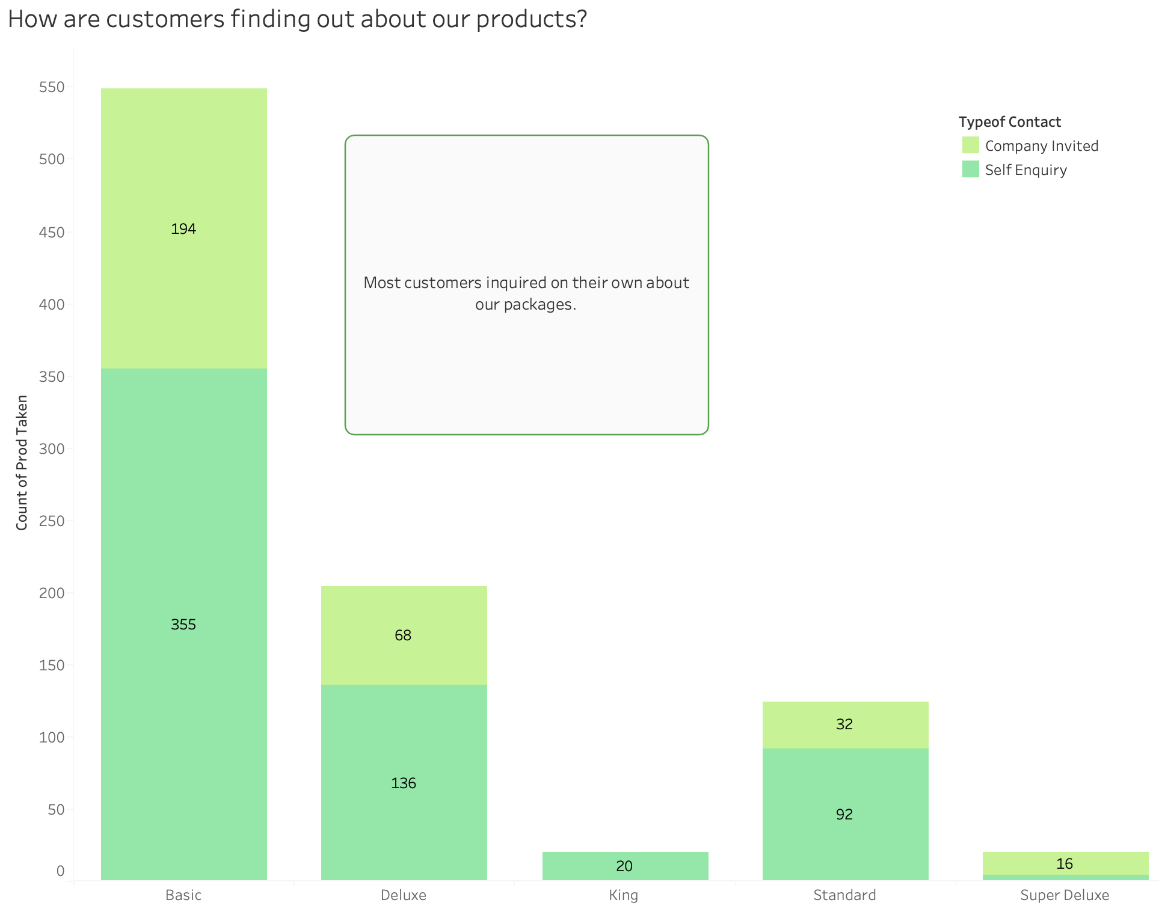

**Customers that Convert to Sales:**

Here we are taking a look at our total customer base (people reached out to us about our products). While the youngest age groups, specifically under 30, have the highest product conversion rate, the older age groups tend to make more trips but have fewer product conversions. The concern raised is why there isn't a higher conversion of packages for these older age groups despite the increased number of trips.

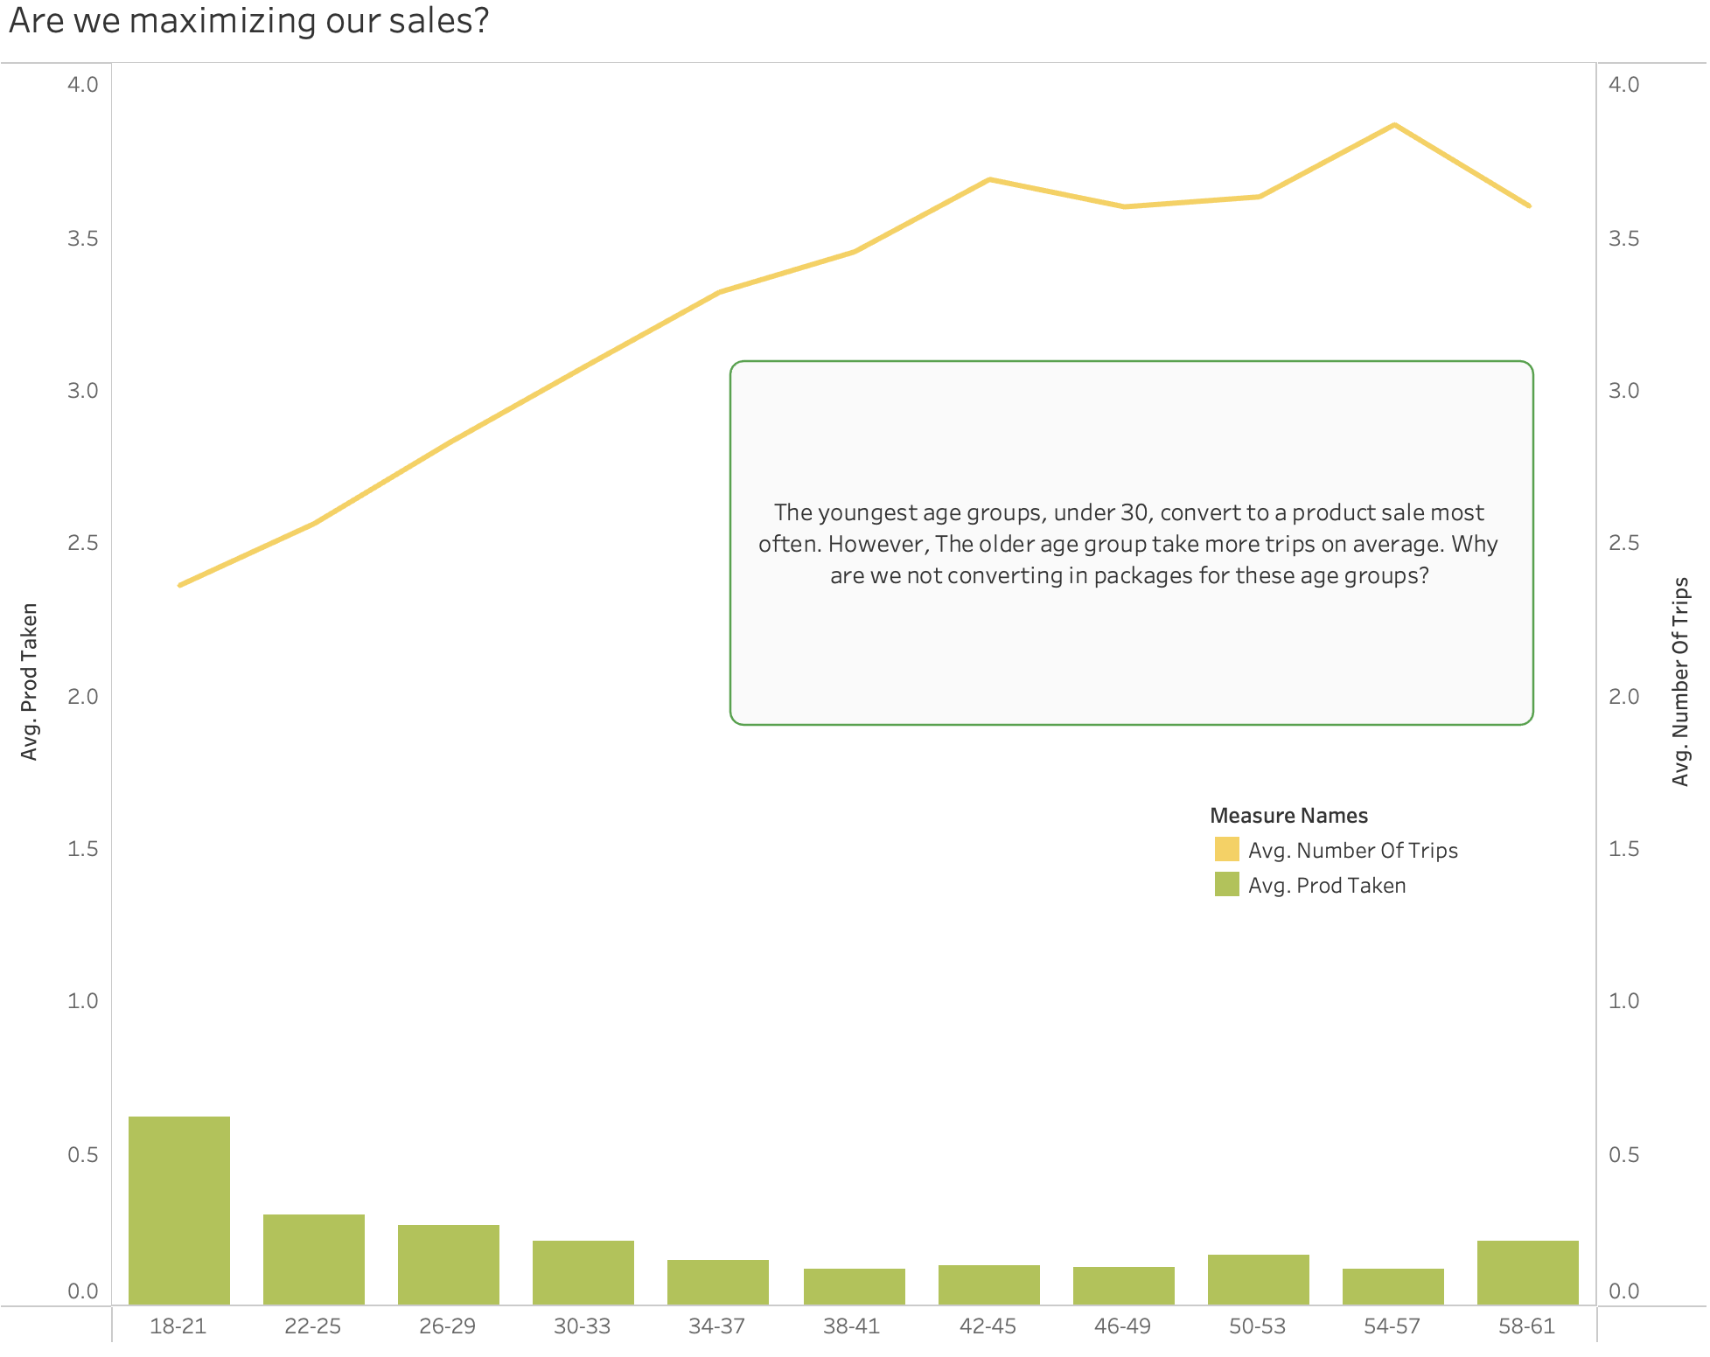

### 

### Standard Package Insights

**Purchases by Age and Gender:**

This visual was meant to show an overview of age and gender, the first factors we look at first when exploring the standard package target market. This will allow us to look further into more features of our target customer. A stacked bar chart is the best option to show this data since it compares both age and gender through a simple lens: bar height and color distribution. The graph depicts that men between the ages of 36 and 44 make up the majority of our customers.

**Purchases by Marital Status of Men 36-44:**

Still focusing on our target customer, men of ages 36-44, this graph highlights marital status categories, and depicts the group with the largest concentration. The majority of our customers appear to be married.

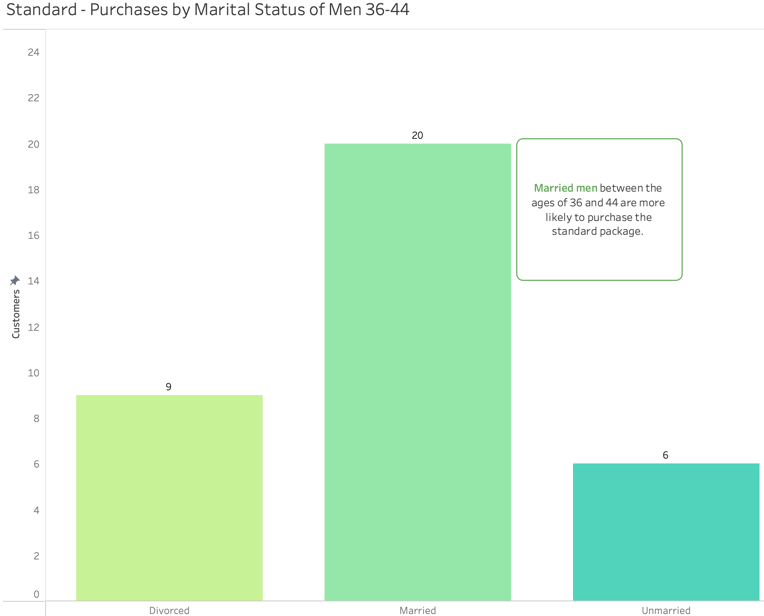

**Purchases by Children Count of Men 36-44:**

Here is a deeper dive into our updated target market, married men between the ages of 36-44, to calculate the frequency of the number of children they brought. We are able to see that the majority of these customers brought 1-2 children.

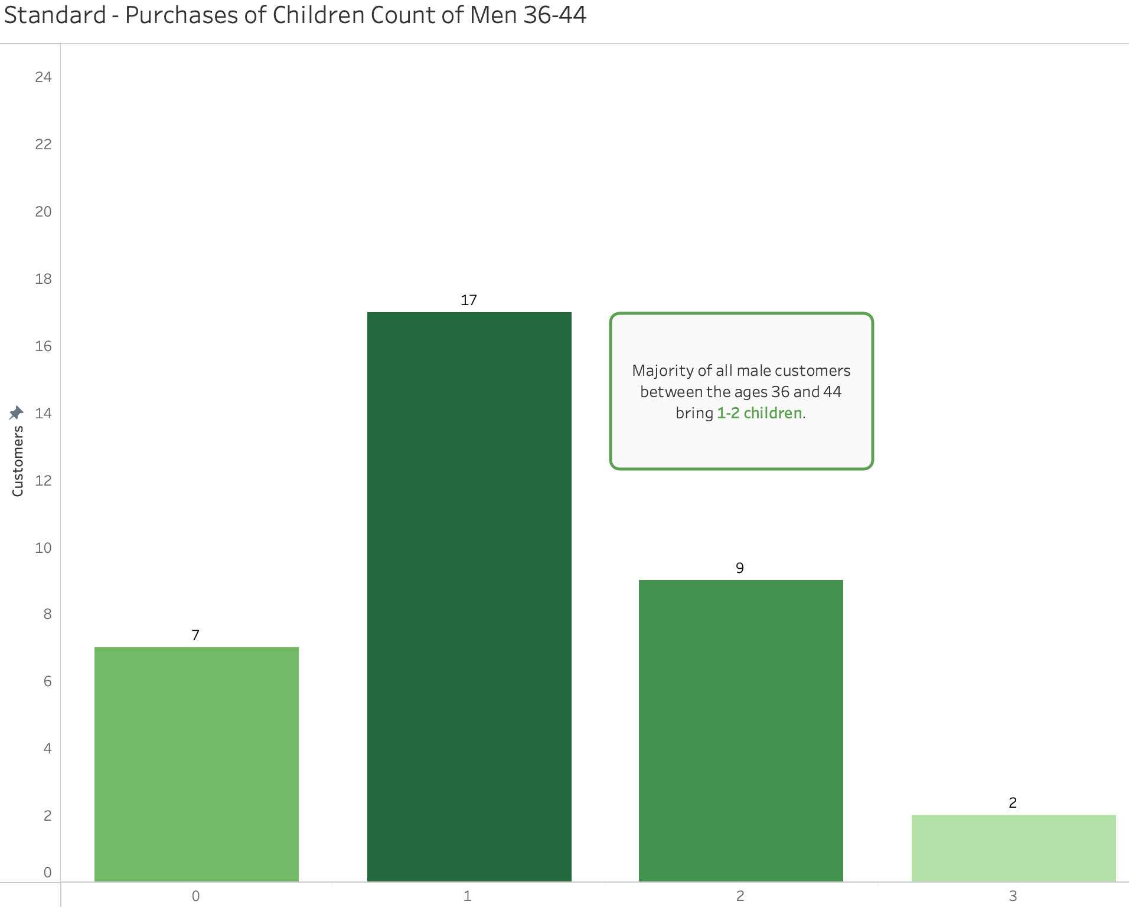

**Purchases by City Tier of Men 36-44:**

For this section, the city tier depends on the development of a city, population, facilities, and living standards. The following chart shows that men between the ages of 36-44 are most likely to reside in a tier 3 city. Promoting value within our packages will appeal to even more customers in tier 3 cities.

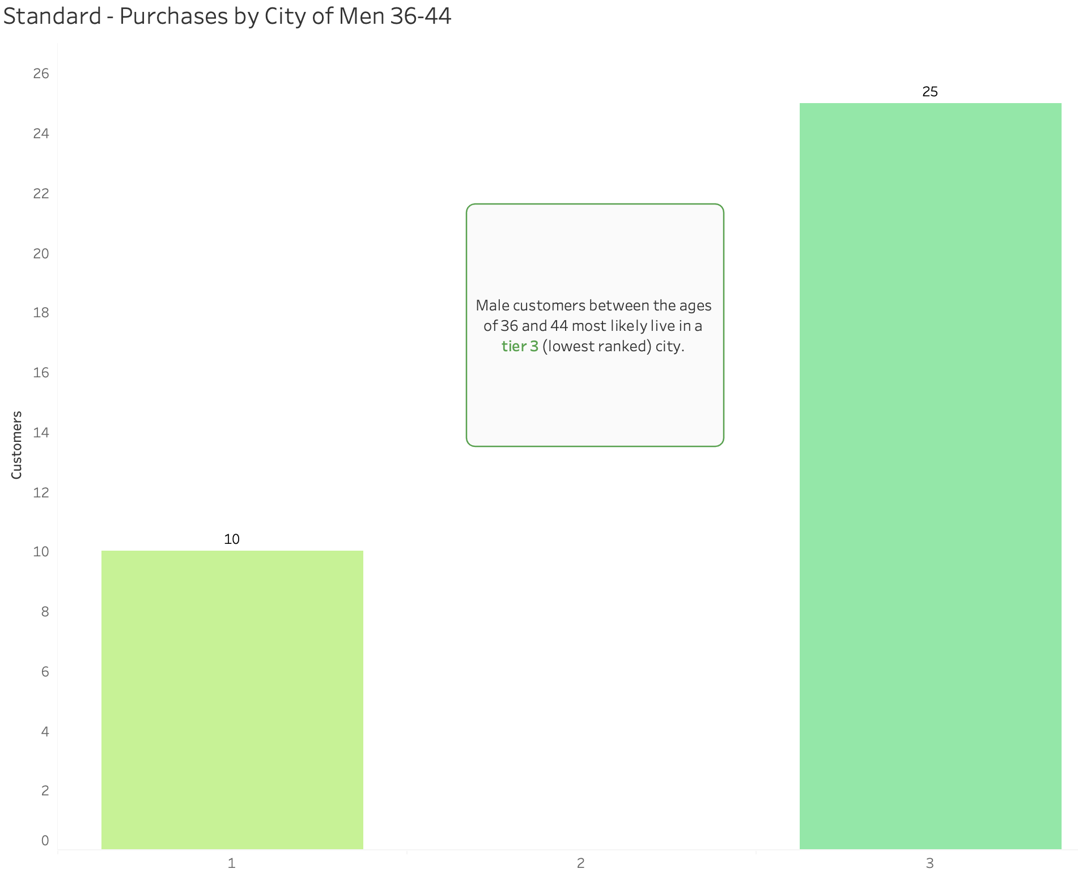

**Purchases by Monthly Income of Men 36-44:**

The last chart for the standard package only focuses on men ages 36-44, however, monthly income is now an added element. Customers with a monthly income between 21.5k and 32.5k make up about 97% of all customers buying the standard package.

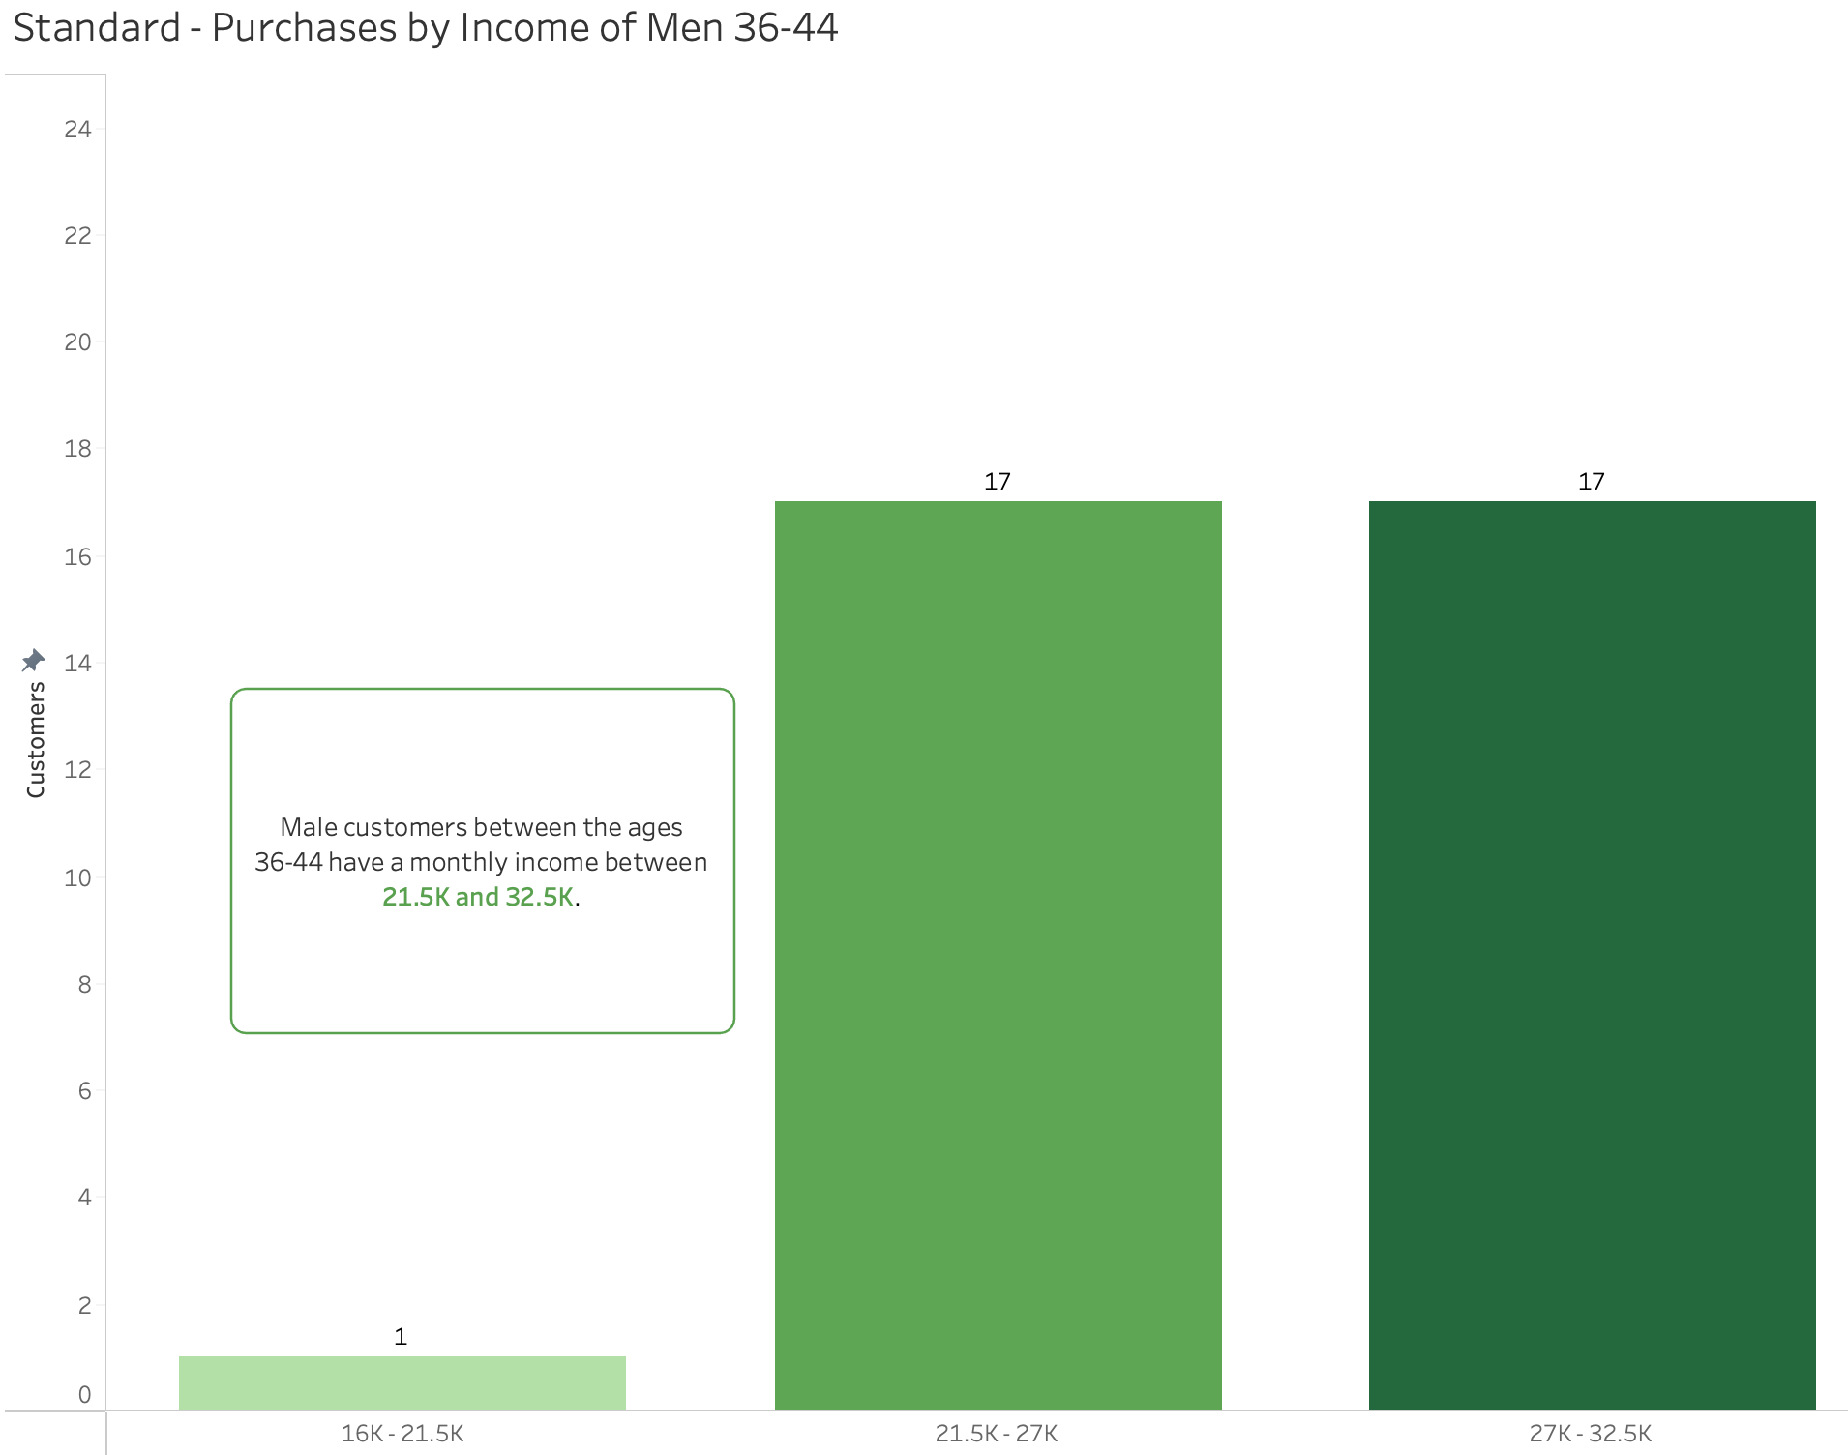

### Deluxe Package Insights

**Purchases by Age and Gender:**

This visual mirrors the chart for the standard package analysis. This allows us to look further into more features of our target customer. Once again, a stacked bar chart is the best option to show this data since it compares both age and gender through a simple lens: bar height and color distribution. For the deluxe package, the visualization below shows us that the majority of our customer base are men between the ages of 30 and 37.

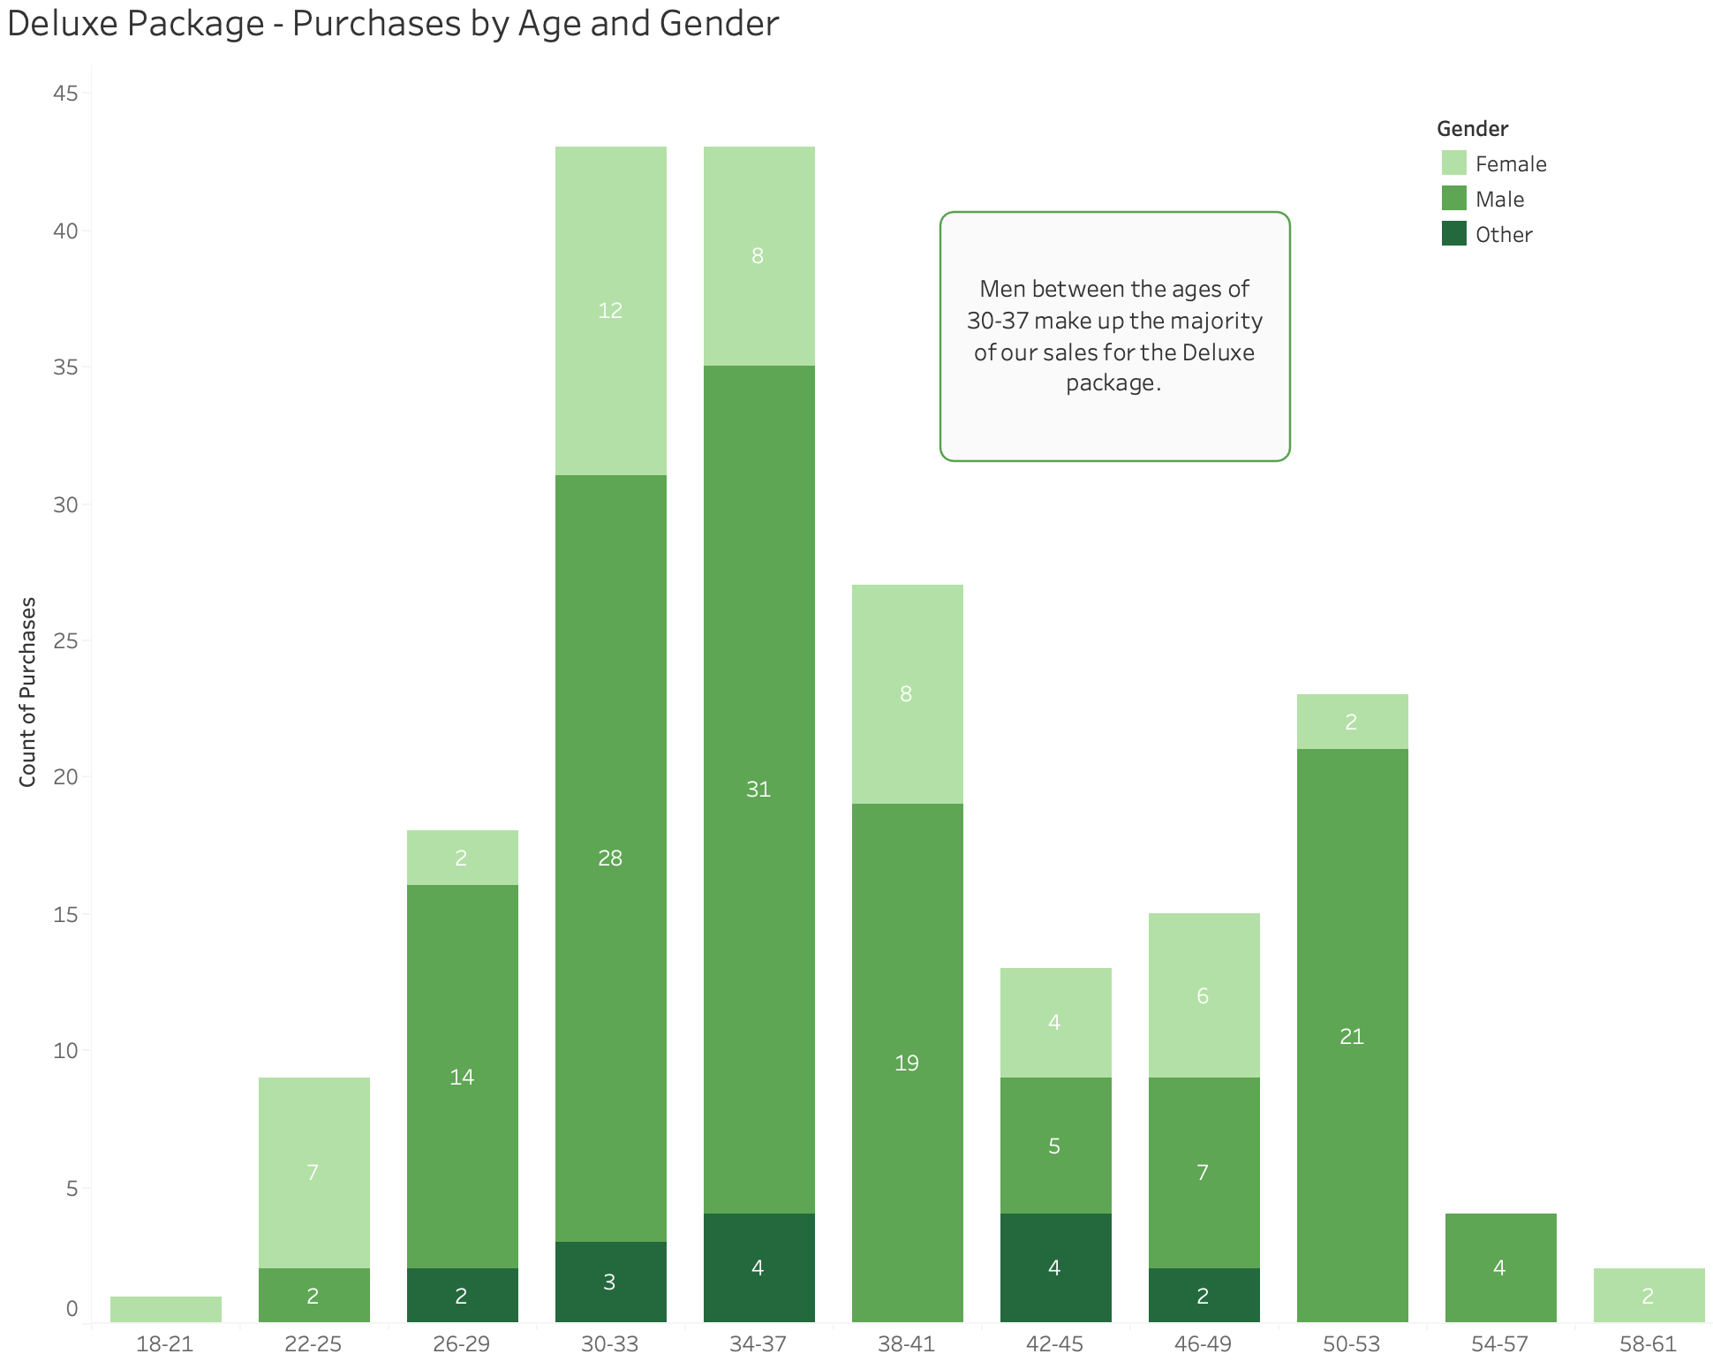

**Purchases by Marital Status of Men 30-37:**

Here we focus on men of ages 30-37, this graph highlights marital status categories, and depicts the group with the largest concentration. The majority of our customers appear to be married. This is able to give our marketing team insights on the most effective way to position our packages to appeal to these married men.

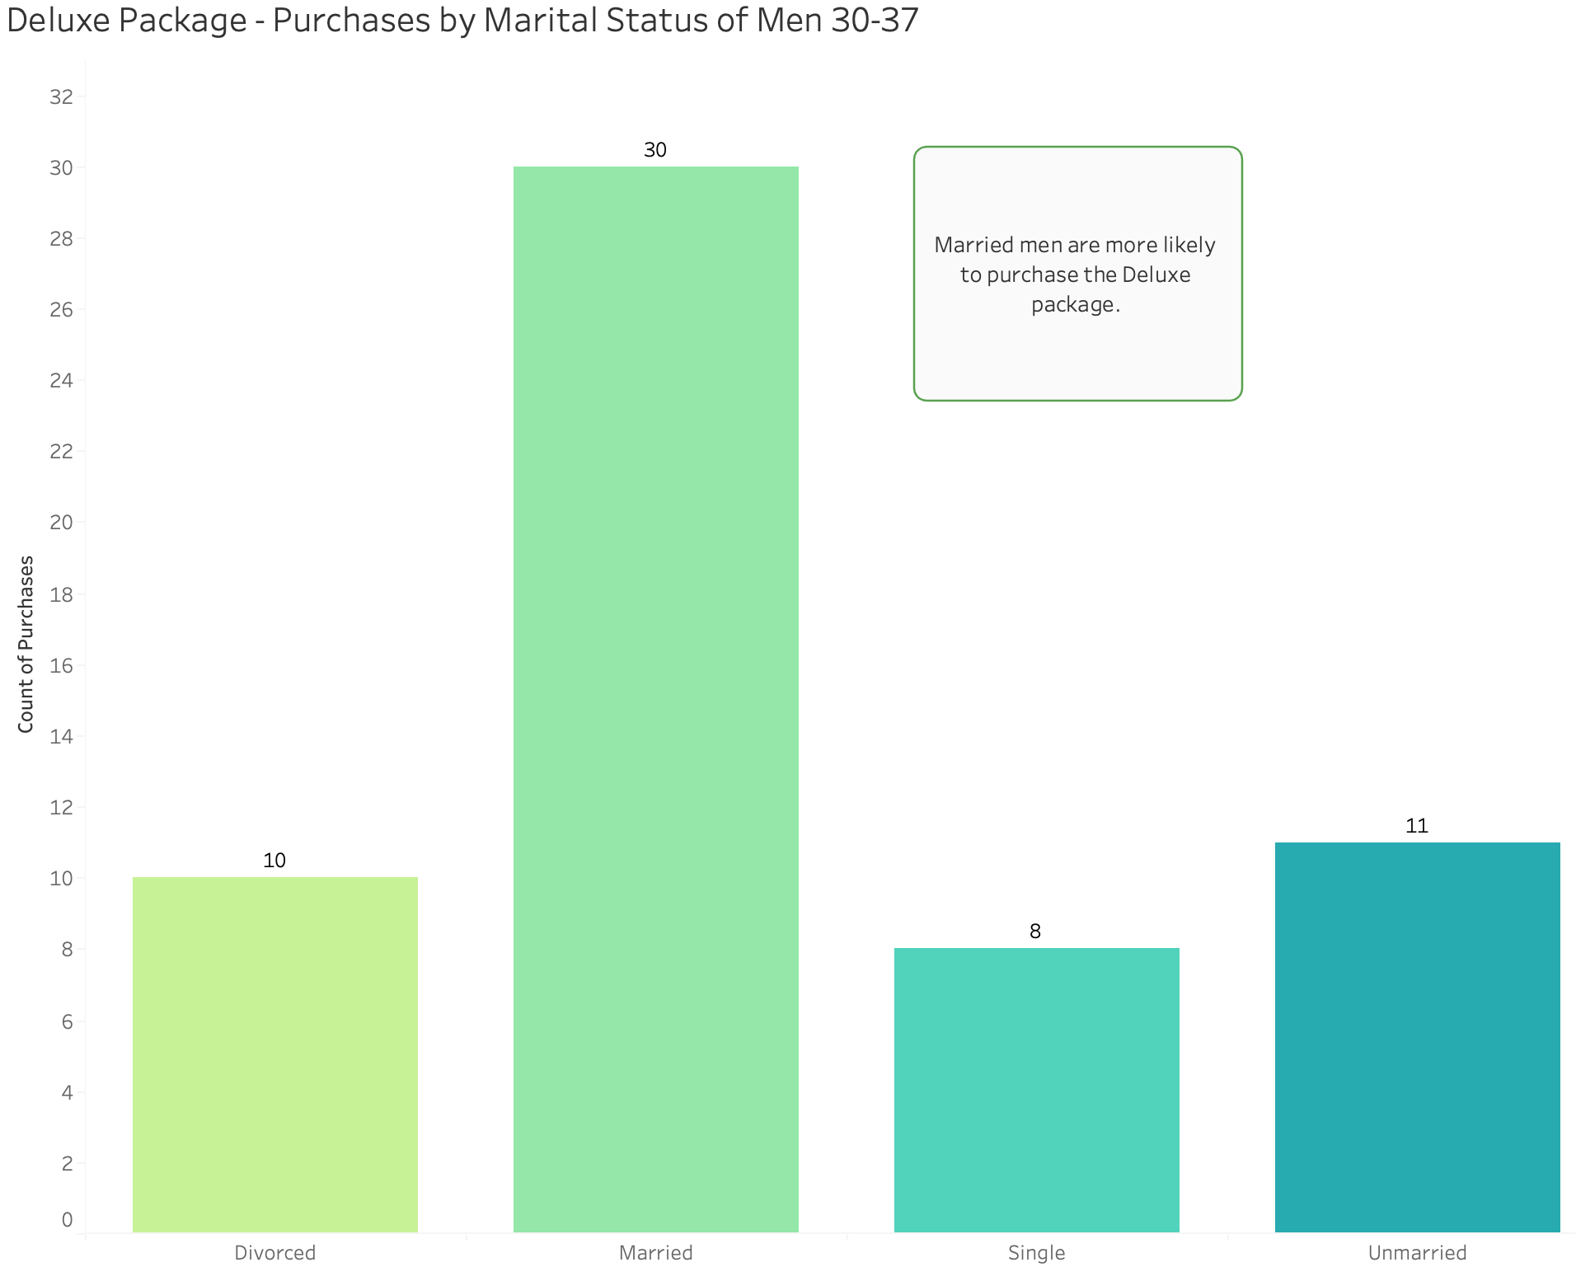

**Purchases by Number of Children of Men 30-37:**

Here is a visual focusing on our updated target market, married men between the ages of 30-37, to calculate the frequency of the number of children they brought. We are able to see that the majority of these customers brought 1-2 children.

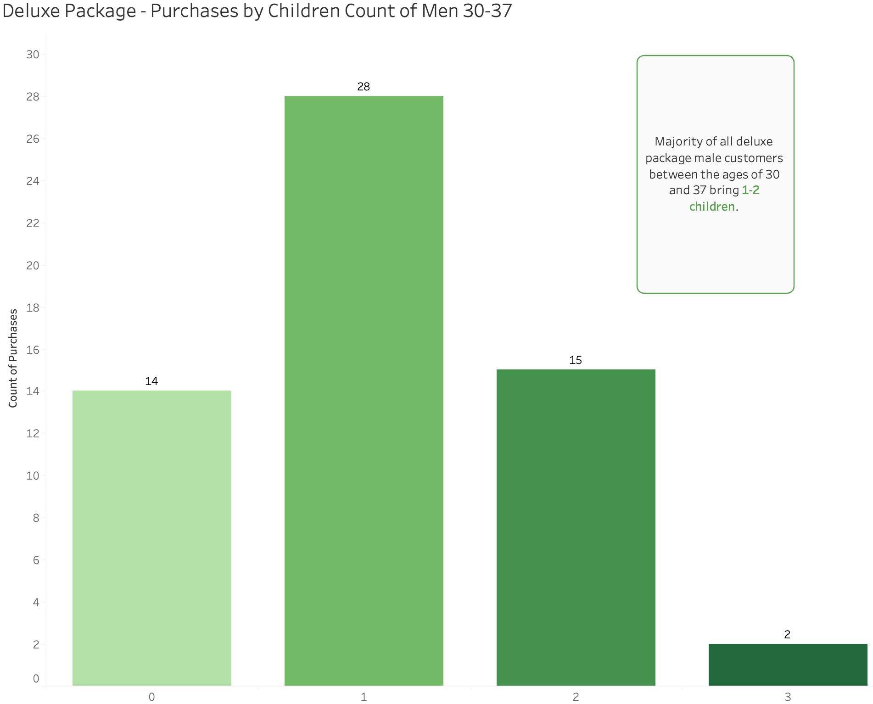

**Purchases by City Tier of Men 30-37:**

As stated in the standard package section above, the city tier depends on the development of a city, population, facilities, and living standards. The following chart shows that men between the ages of 30-37 are most likely to reside in a tier 3 city. Once again, marketing value within our packages will appeal to even more customers in tier 3 cities.

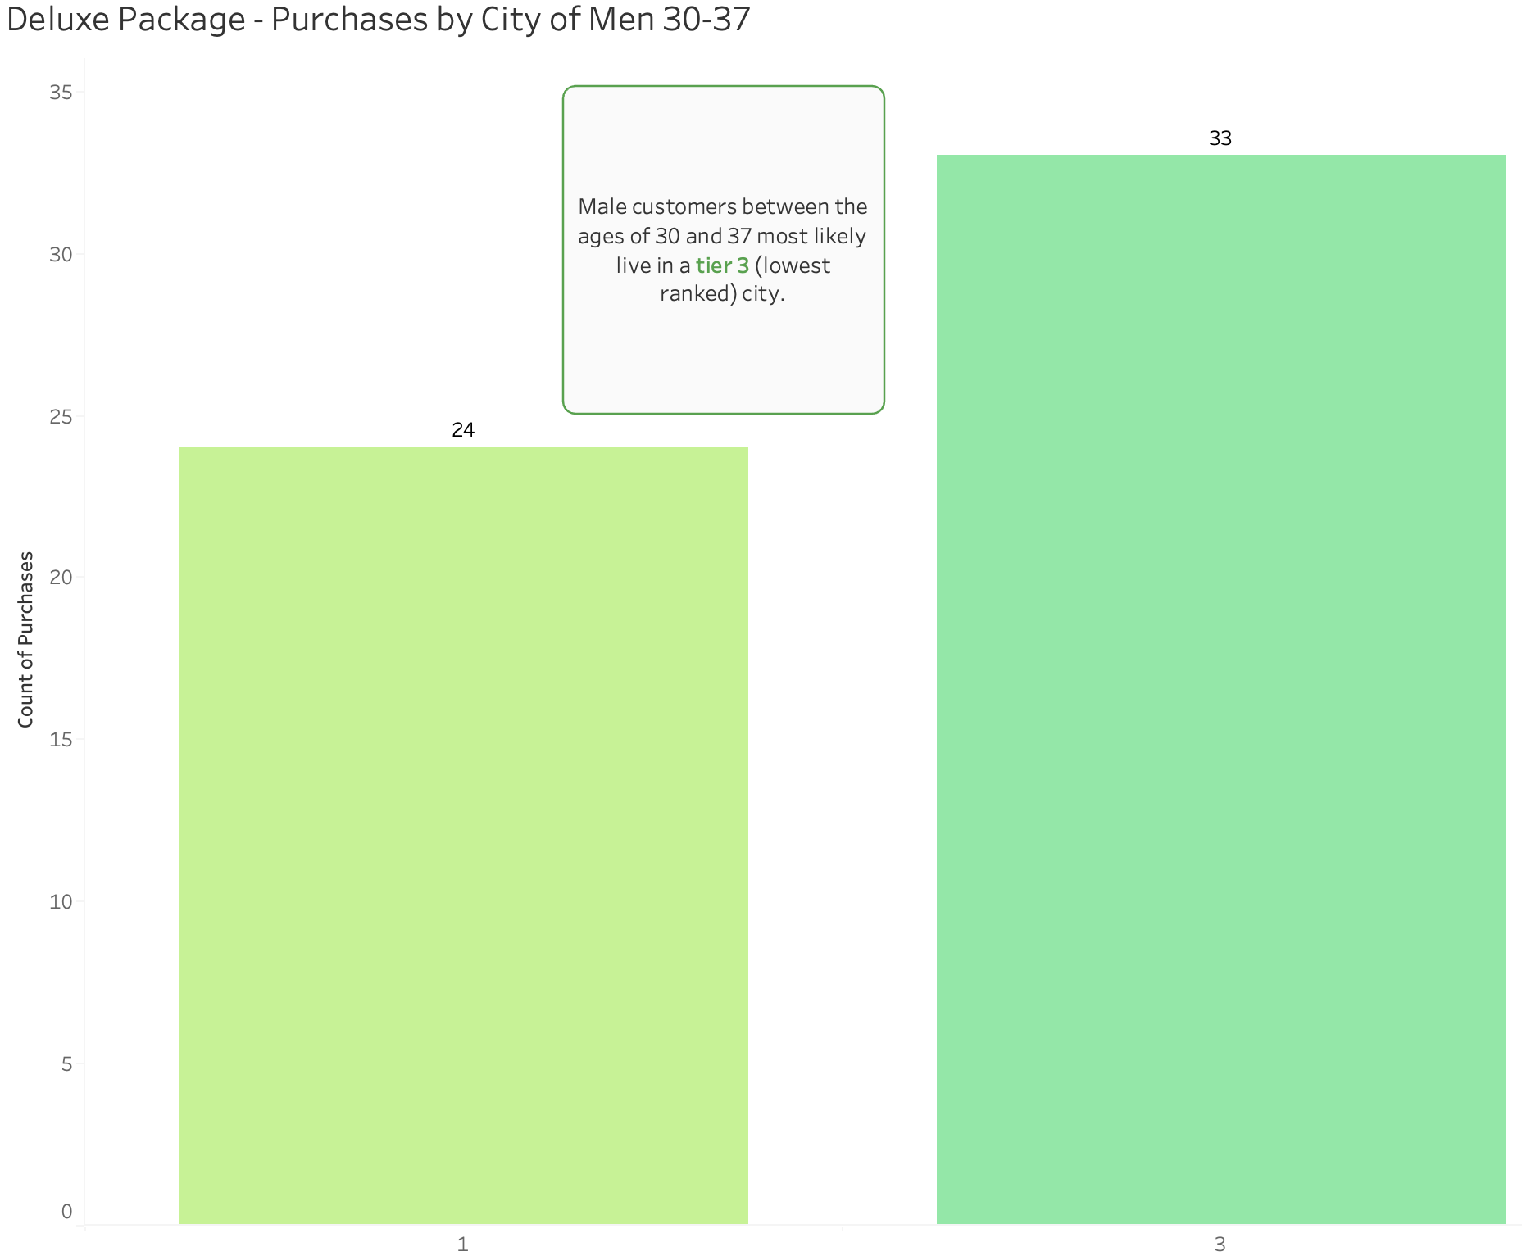

**Purchases by Monthly Income of Men 30-37:**

The final chart for the deluxe package again only focuses on men ages 30-37, however, monthly income is now an added element. Customers with a monthly income between 16k and 27k make up the majority of our deluxe customers.

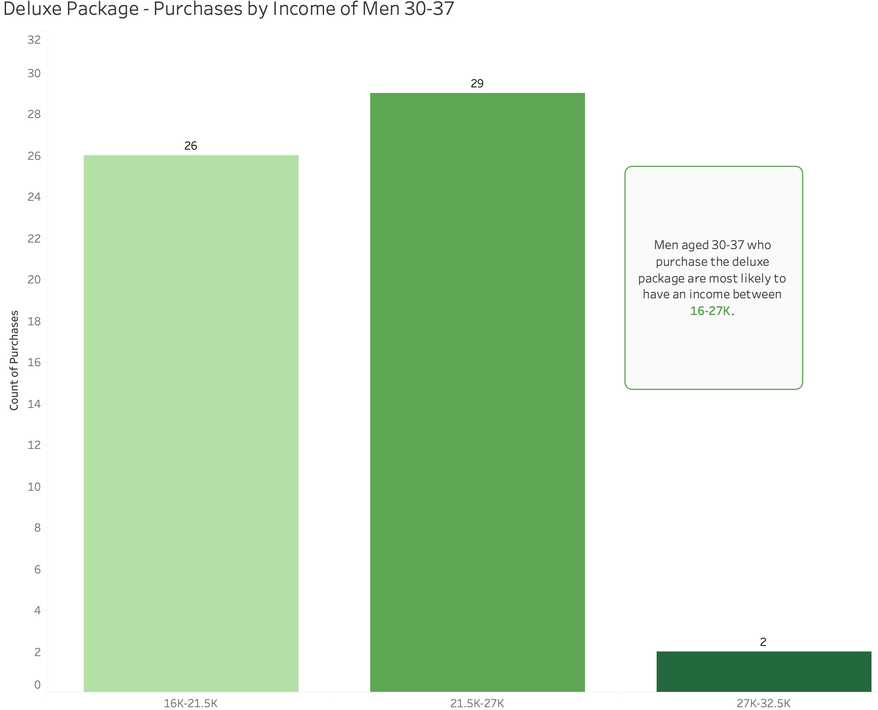

# 

# **Executive Summary & Tableau Workbook**

### Email Deliverable for Audience Members

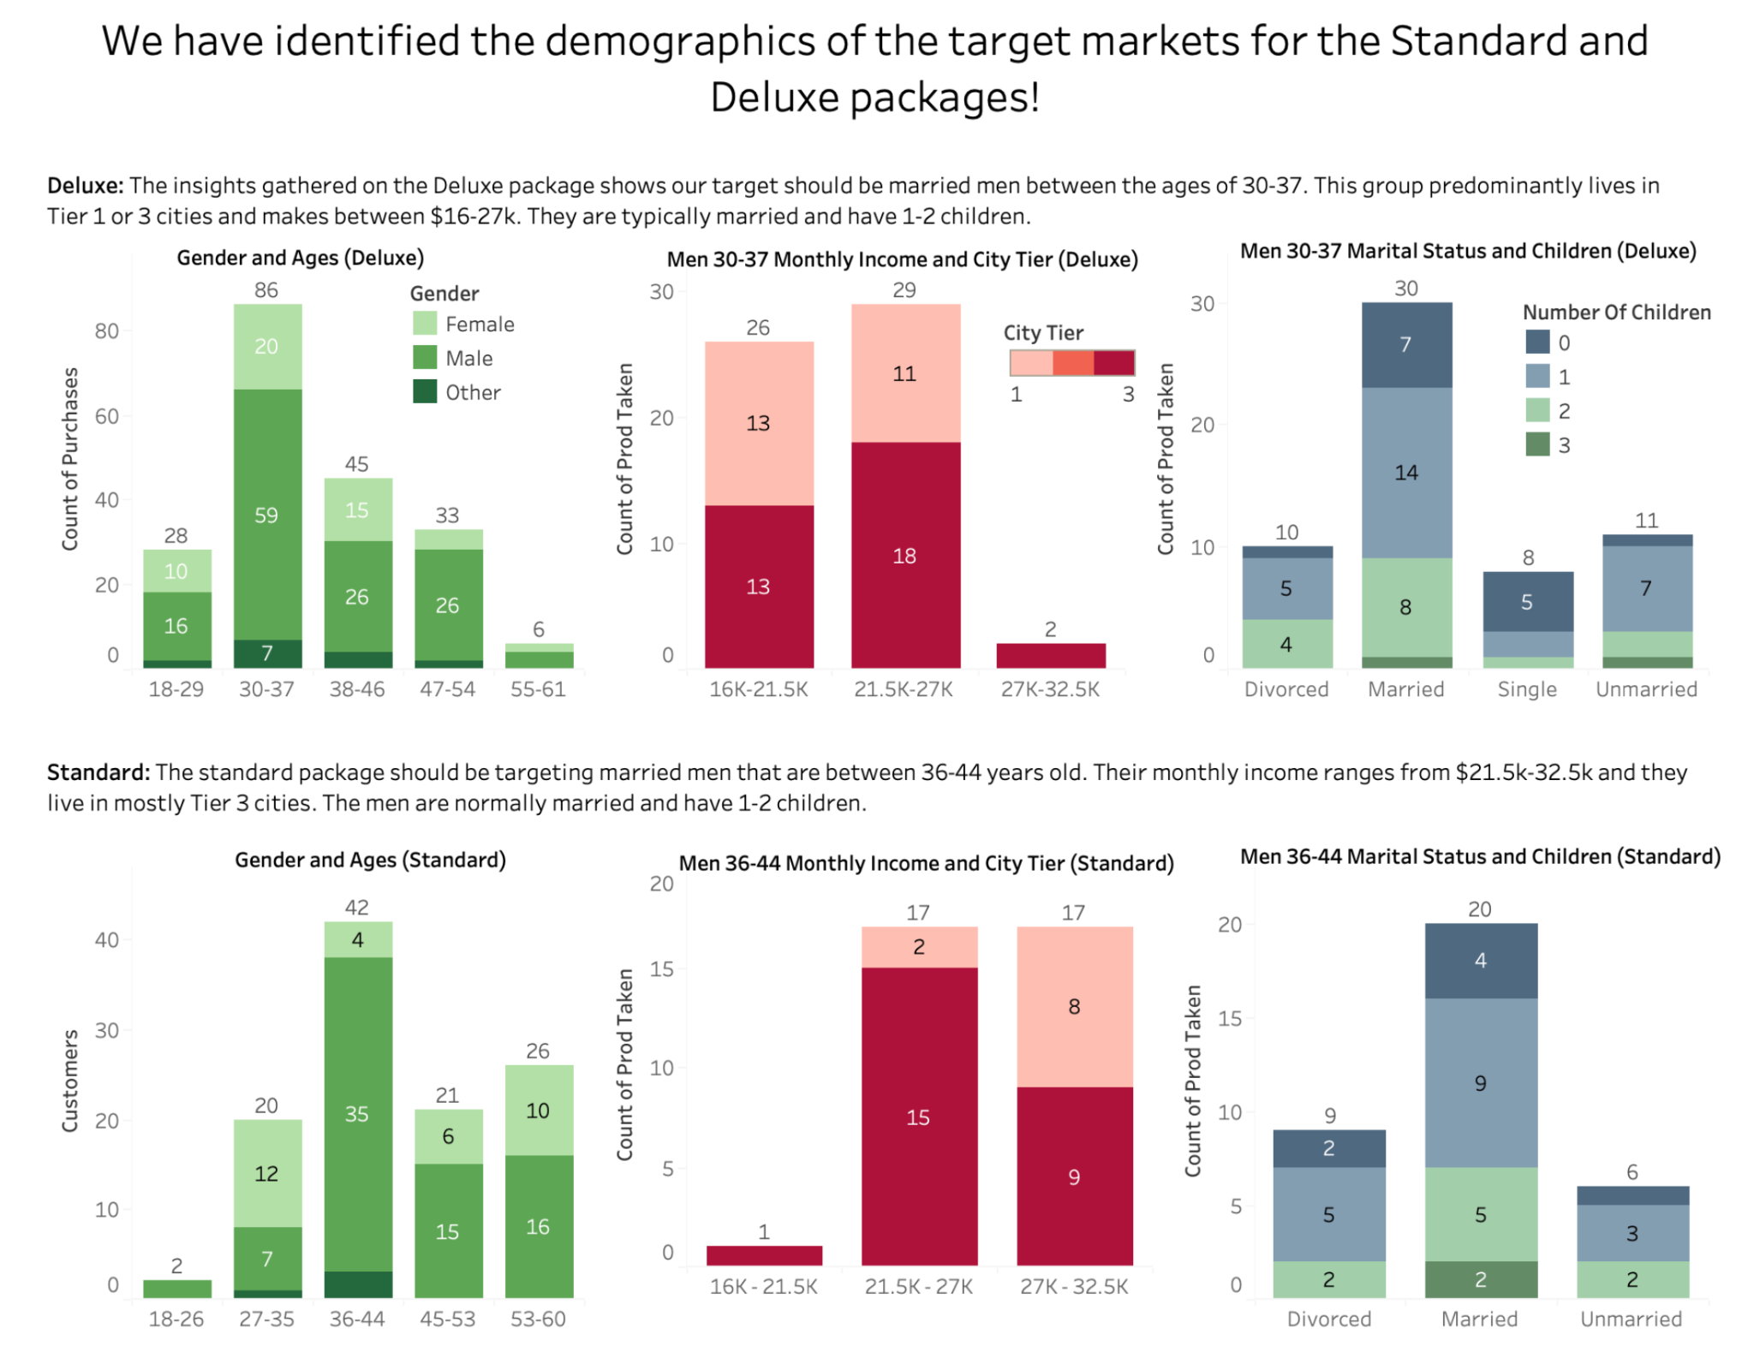

[Link to download PDF](https://drive.google.com/file/d/1cMvqjJO34nZiJD_CNQTpPUMOB0CVHXSf/view?usp=sharing)

### Tableau Workbook File

[Link to download Tableau workbook](https://drive.google.com/file/d/1hD1TpiuZMKizzg3W-_SX2ApO_zIe8Axc/view?usp=sharing)